**LAUNDRY BOOKING SYSTEM**

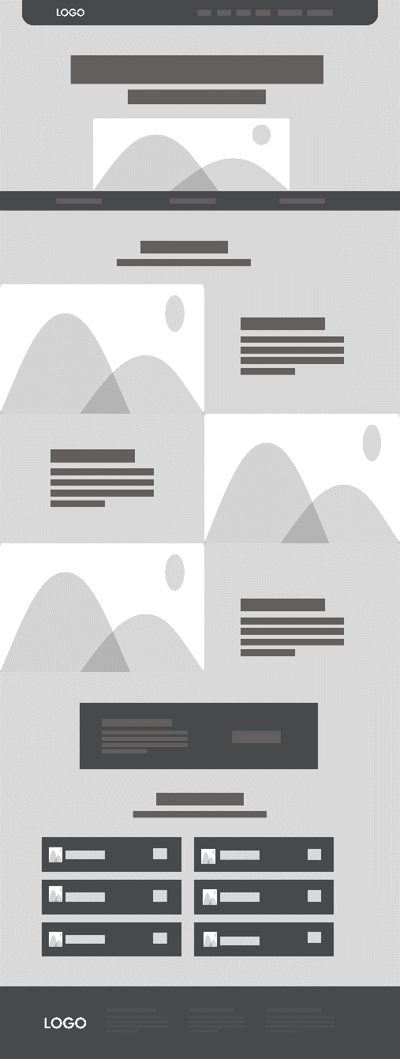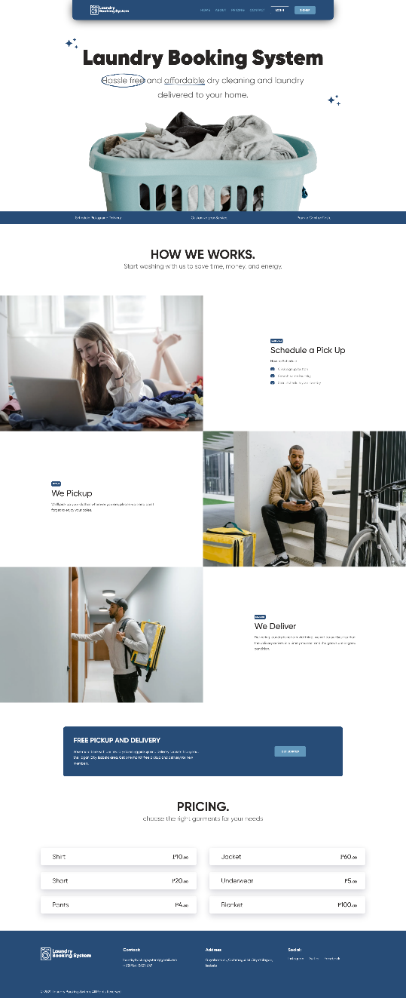 **Low-level Prototype High-level Prototype**